Paul’s Eulogy

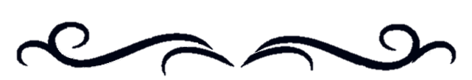

Bilogone but not forgotten<3

Ad memoriam

Paul Bilokon

He could open his balls but not his emails

Textbook part 2 died with him

More Like Paul Bilogone AMIRIGHT

May he Rest In Peace

To any future first years reading this: don’t ever trust paul 🙁

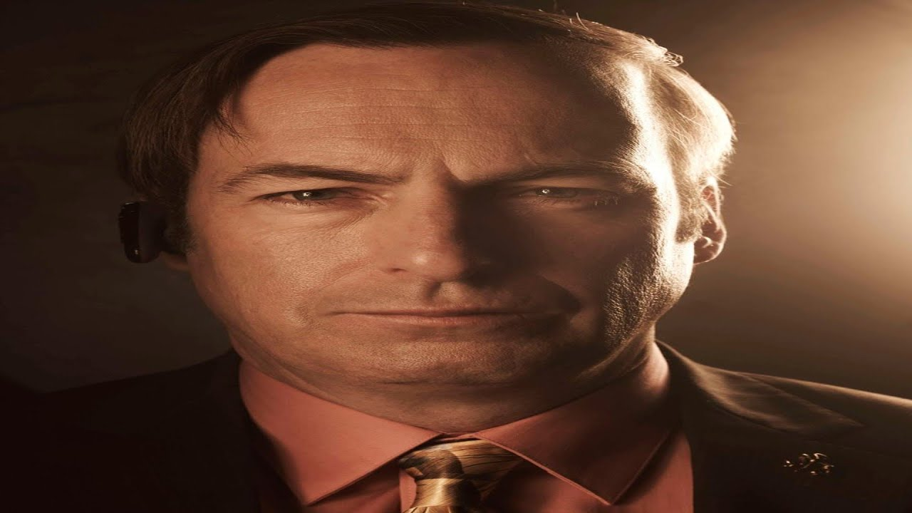

Ratio of balls to your mouth

Balls open, like my DMs. @haash.im

